Utagawa Kunisada II

琴碁書画 源氏六色合

1869

[Miyagawa Shuntei](http://ukiyo-e.org/artist/miyagawa-shuntei)囲碁

囲碁師範[Wada Sanzo](http://ukiyo-e.org/artist/wada-sanzo)

|  |  |
| --- | --- |
|  | 棊 |

<http://ja.ukiyo-e.org/image/waseda/006-0161>

[Utagawa Kunisada](http://ukiyo-e.org/artist/utagawa-kunisada)

|  |  |
| --- | --- |
|  | 歌川国貞 |

Utagawa Kunisada

歌川国貞

**歌川豊国**

**Utagawa Toyokuni** (1769- 24 février 1825)

棊

**om the set Yakusha Gei Zukushi (Artistic Accomplishments of Actors).**   
**The famous actor Matsumoto Koshiro V sits at the go board**   
**wearing an informal summer kimono with a pattern of**   
**Ginkgo leaves in reverse on a lavender gr**

Woodblock prints by Utagawa Toyokuni I

Japanese Ukiyo-e printmaker, 1769-1825

depicting Ginkgo leaves pattern

An actor playing Go

Fan print by Toyokuni, Japan, c. 1810s.

Subtitle Go, from the set Yakusha Gei Zukushi (Artistic Accomplishments of Actors).

The famous actor Matsumoto Koshiro V sits at the go board

wearing an informal summer kimono with a pattern of

Ginkgo leaves in reverse on a lavender ground.

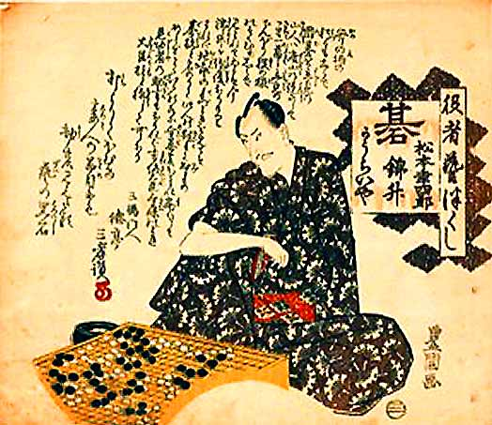

**Une estampe originale de KUNISADA appelé aussi TOYOKUNI III**   
(1786-1865)  
nom de famille : Utagawa

Titre : Aristocrate dérangé lors d'une partie de go

Date du tirage : 7ème mois de 1854  
  
Signature : Toyokuni ga ("dessiné par Toyokuni") dans un cartouche rouge Toshidama  
(Le sceau rond et le cartouche Toshidama sont la marque des artistes qui se rattachent à l'école Utagawa.)  
  
Editeur : Maru-ya Jimpachi  
  
Cachets de censure : un cachet portant le caractère " aratame " (examiné) et un cachet zodiacal indiquant le 7ème mois de l'année du tigre, ce qui permet de dater l'estampe de 1854.  
  
Etat : Couleurs et traits de contours parfaits. Salissures sur quelques centimètres sur une zone allant du visage du personnage jusqu'au montant de la terrasse derrière lui. Très bon état général.

Format oban : 36,2 cm x 24,6 cm (UK205)

**Sujet** : Un jeune aristocrate est assis sur la terrasse d'un pavillon donnant sur un jardin orné d'une lanterne de pierre. Ce jardin planté de pins longe le bord d'un lac. Il porte un hakama (pantalon très large) richement décoré de motifs de fleurs et un kimono court gris décoré du mon (emblème) de son clan. Il referme son éventail et semble prêt à sortir son sabre. Il semble être dérangé au milieu d'une partie de go. Des pions de jeu noirs et blancs sont dispersés sur le sol derrière lui.

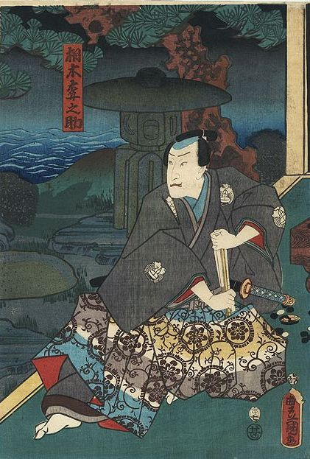

## [Estampe Originale de Toyokuni III/Kunisada (1786 – 1864), le jeu de Go](http://atelierstromain.com/2012/11/18/estampe-originale-de-toyokuni-iiikunisada-1786-1864-le-jeu-de-go/)

Le jeu de Go

Scène de kabuki où les acteurs sont en conversation devant un jeu de Go.

*Originaire de Chine, le jeu de go oppose deux adversaires qui placent à tour de rôle des pierres noires et blanches sur échiquier tentant ainsi de contrôler le jeu en y construisant des « territoires ». Chaque « pierre » représente un soldat Les soldats encerclés deviennent des prisonniers. Il s’agit du plus ancien jeu de stratégie combinatoire abstrait connu. Malgré son ancienneté, le jeu de go continue à jouir d’une grande popularité au Japon, en Corée et en Chine. Son succès tient autant à la simplicité de ses règles qu’à sa grande richesse combinatoire et sa profondeur stratégique.*

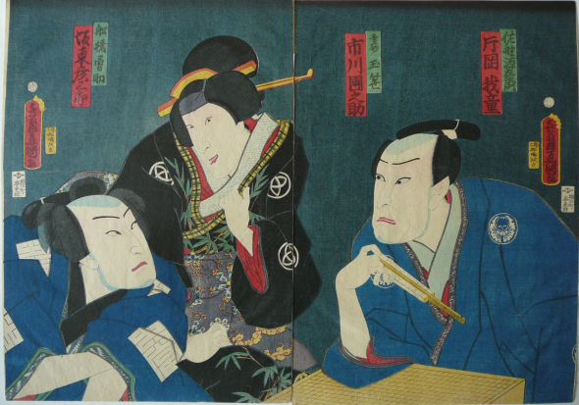

Utagawa Toyokuni

Joueuse de go à la cour impériale du Prince Genji

#### Parade des gâteaux de riz (Faux)

Il n'y a pas de jeu de go dans l'Estampe de Chikanobu (1838 – 1912).  
Celui-ci y a été incorporé pour une couverture comme c'est le cas pour un certain nombre de revues japonaises ou coréennes.

#### Amusements d'un soir d'été... (Faux)

A priori il s'agit d'une copie où le go-ban a été introduit dans l'image à la place d'un autre élément.  
C'est le cas pour un certain nombre de couvertures de revue de go, "trafiquées" à partir d'estampe traditionnelle.  
Voir ci-après l'estampe originale.

#### Amusements un soir d'été

par Eishi Chobunsai (1756-1829)  
On voit qu'il n'y a pas de jeu de go mais une table basse avec un plat de poisson.

Lot de deux boîtes avec galets de jeu de go. Housse en brocart. Les deux boîtes sont laquées noires et décorées de vagues. Le couvercle d'une des boîtes est décoré d'une grue japonaise, l'autre d'un corbeau sur fond de coucher de soleil rougeâtre. Dans leur boîte d'origine à décor de papillon. Période Edo. Dim. des boîtes: H.: 10 cm, D.: 11 cm Boîte de rangement: 28,8 x 15,7 cm, H.: 15 cm

No. 30 Onodera Toemon Hidetome 小野寺幸右衛門秀富 / Seichu gishi den 誠忠義士傳 (Biographies of Loyal and Righteous Samurai)

This print belongs to the popular series “The Faithful Samurai”, a series of fifty-one prints depicting the tale of the forty-seven ronin.

Hidetome was the foster son of Onodera Hidekazu. The two of them made their way to Kantô to avenge their master's death and disguised as tradesmen they entered their enemy's mansion while nobody was around.

Hidetome left this poem:

If the lord is wise,

and his retainers good,

the people are happy.

The lord is like the head,

and the retainers the members.

If all is clear above,

all is good below.

If the lord is virtuous,

loyalty abides.

This is what we pray for:

This morning early

not even one word of mouth

passes among us,

as, for our lord's sake alone,

the dew begins to gather.

In this print Hidetome is tying his sandal on a tipped go-board.

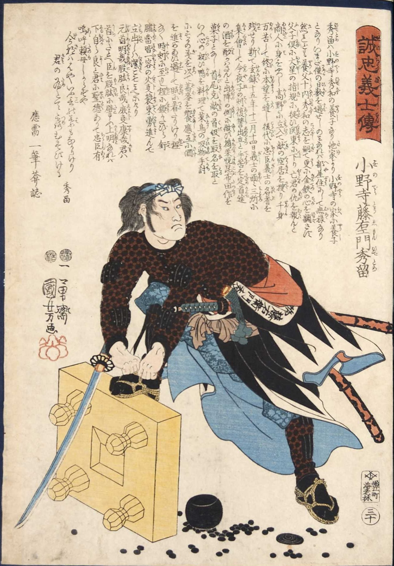

小野寺藤右エ門秀富

**誠忠義士伝 小野寺藤右ェ門秀留**

44. Utagawa Kuniyoshi (1797-1861)

The ronin Onodera Toemon Hidetome resting his foot on

an upturned

go board to tie the lace of his sandal.

From the same series as last published by Ebi-ya

Rinnosuke in 1847-48.

Signed

Ichiyusai Kuniyoshi ga, kiri

seal.

Format

oban

, 36,1x25 cm. Robinson 1982, S54.30

**Title**: *Satô Shirô Tadanobu Horikawa no tachi wo ochiru* etc.

**Description**: Satô Tadanobu standing at bay before his attackers with the *go* board overturned

**Publisher**: Ezaki-ya Tatsuzô

**Date**: 1845

**Robinson**: T168

|  |  |
| --- | --- |
| *Sato Tadanobu, a Samurai of the Twelfth Century, Defending Himself with a Goban when Attacked by His Enemies*. Ukiyo print by [Utagawa Kuniyoshi](https://en.wikipedia.org/wiki/Utagawa_Kuniyoshi) | |
| **Native name** | 佐藤 忠信 |
| **Born** | 1161 |
| **Died** | November 1186 (aged 24–25) |
| **Nationality** | Japanese |
| **Other names** | Shirō, 四郎兵衛尉 |

In this [Japanese name](https://en.wikipedia.org/wiki/Japanese_name), the family name is Satō.

|  |  |
| --- | --- |
| **Satō Tadanobu** | |
| [250px](https://en.wikipedia.org/wiki/File:Sato_Tadanobu_with_a_goban.jpeg)  *Sato Tadanobu, a Samurai of the Twelfth Century, Defending Himself with a Goban when Attacked by His Enemies*. Ukiyo print by [Utagawa Kuniyoshi](https://en.wikipedia.org/wiki/Utagawa_Kuniyoshi) | |
| **Native name** | 佐藤 忠信 |
| **Born** | 1161 |
| **Died** | November 1186 (aged 24–25) |
| **Nationality** | Japanese |
| **Other names** | Shirō, 四郎兵衛尉 |

**Satō Tadanobu** (佐藤 忠信[**?**](https://en.wikipedia.org/wiki/Help:Installing_Japanese_character_sets)) was a Japanese [samurai](https://en.wikipedia.org/wiki/Samurai) of the late-[Heian Period](https://en.wikipedia.org/wiki/Heian_Period). He was a follower of [Minamoto no Yoshitsune](https://en.wikipedia.org/wiki/Minamoto_no_Yoshitsune). According to the [*Genpei Jōsuiki*](https://en.wikipedia.org/wiki/Genpei_J%C5%8Dsuiki), he was one of the *Yoshitsune Shitennō* (義経 四天王[**?**](https://en.wikipedia.org/wiki/Help:Installing_Japanese_character_sets), literally "Yoshitsune's [Four Heavenly Kings](https://en.wikipedia.org/wiki/Four_Heavenly_Kings)"), along with [Kamata Morimasa](https://en.wikipedia.org/w/index.php?title=Kamata_Morimasa&action=edit&redlink=1), [Kamata Mitsumasa](https://en.wikipedia.org/w/index.php?title=Kamata_Mitsumasa&action=edit&redlink=1), and [Satō Tsugunobu](https://en.wikipedia.org/wiki/Sat%C5%8D_Tsugunobu). He was the younger brother of Tsugunobu, and their father was the [Ōshū Fujiwara](https://en.wikipedia.org/w/index.php?title=%C5%8Csh%C5%AB_Fujiwara_clan&action=edit&redlink=1) retainer [Satō Motoharu](https://en.wikipedia.org/w/index.php?title=Sat%C5%8D_Motoharu&action=edit&redlink=1).

## Yoshitsune's retreat

Satō is most well known for saving his master Yoshitsune's life at [Yoshino](https://en.wikipedia.org/wiki/Yoshino_Province), a story recorded in the [*Gikeiki*](https://en.wikipedia.org/wiki/Gikeiki). The story has become somewhat legendary over the years. Whilst travelling to [Kyushu](https://en.wikipedia.org/wiki/Kyushu) to escape from the troops of his brother [Yoritomo](https://en.wikipedia.org/wiki/Minamoto_Yoritomo), Yoshitsune and his forces were beset by the monks of Zo-o-no, and were facing defeat. Satō volunteered to fight a rearguard action to allow Yoshitsune time to reach safety, and asked for the loan of his master's armour in order to convince the pursuing toops that Yoshitsune was still within their grasp. (This was not an entirely selfless act, since Yoshitsune's armour would have been of better quality than Satō's, and would have afforded better protection.)[[1]](https://en.wikipedia.org/wiki/Sat%C5%8D_Tadanobu#cite_note-Turnbull2012-1) Disguised as Yoshitsune, Satō challenged and fought the group's pursuers, killing or wounding around twenty men.[[2]](https://en.wikipedia.org/wiki/Sat%C5%8D_Tadanobu#cite_note-Inc.1975-2) His companions were killed, but Satō evaded capture and proceeded to [Kyoto](https://en.wikipedia.org/wiki/Kyoto).[[3]](https://en.wikipedia.org/wiki/Sat%C5%8D_Tadanobu#cite_note-Brinkley-3) In Kyoto he stayed at the house of a woman acquaintance, but was discovered and attacked. Under threat of capture, he committed [seppuku](https://en.wikipedia.org/wiki/Seppuku).[[2]](https://en.wikipedia.org/wiki/Sat%C5%8D_Tadanobu#cite_note-Inc.1975-2) His widow, Kaede, along with her sister-in-law Wakazakura, attempted to comfort his grieving mother by presenting herself wearing her late husband's armour.[[1]](https://en.wikipedia.org/wiki/Sat%C5%8D_Tadanobu#cite_note-Turnbull2012-1)

## "Goban" Tadanobu

A popular story regarding Satō Tadanobu's death involves him being attacked whilst playing a game of [go](https://en.wikipedia.org/wiki/Go_%28game%29). Unable to reach his weapons, he is said to have picked up the [goban](https://en.wikipedia.org/wiki/Go_equipment#Board) and used it to fight off his enemies before eventually killing himself. This episode has been a popular theme in [*ukiyo*](https://en.wikipedia.org/wiki/Ukiyo) prints,[[1]](https://en.wikipedia.org/wiki/Sat%C5%8D_Tadanobu#cite_note-Turnbull2012-1)[[4]](https://en.wikipedia.org/wiki/Sat%C5%8D_Tadanobu#cite_note-Bozulich-4)[[5]](https://en.wikipedia.org/wiki/Sat%C5%8D_Tadanobu#cite_note-Baird2001-5) and has also inspired [*kabuki*](https://en.wikipedia.org/wiki/Kabuki) plays such as *Yoshino Shizuka Goban Tadanobu*[[6]](https://en.wikipedia.org/wiki/Sat%C5%8D_Tadanobu#cite_note-HerwigMostow2007-6) and [*Yoshitsune Senbon Zakura*](https://en.wikipedia.org/wiki/Yoshitsune_Senbon_Zakura), and the *ko-jururi* play *Goban Tadanobu*.[[7]](https://en.wikipedia.org/wiki/Sat%C5%8D_Tadanobu#cite_note-KingIwakiri2007-7) In many of these plays, the Tadanobu character is implied to be a [fox spirit](https://en.wikipedia.org/wiki/Kitsune) ("[Genkurō](https://en.wikipedia.org/wiki/Genkur%C5%8D)"), due to his impersonation of Yoshitsune (in Japan, foxes were believed to be shape-shifters).[[8]](https://en.wikipedia.org/wiki/Sat%C5%8D_Tadanobu#cite_note-Smyers1999-8)

## References

• Stephen Turnbull (19 June 2012). [*Hatamoto: Samurai Horse and Foot Guards 1540-1724*](http://books.google.com/books?id=TqR0rij5b0QC&pg=PT11). Osprey Publishing. pp. 11–12. [ISBN](https://en.wikipedia.org/wiki/International_Standard_Book_Number) [978-1-78200-016-7](https://en.wikipedia.org/wiki/Special:BookSources/978-1-78200-016-7). Retrieved 26 April 2013.

• • Active Interest Media, Inc. (January 1975). [*Black Belt*](http://books.google.com/books?id=ddgDAAAAMBAJ&pg=PA38). Active Interest Media, Inc. pp. 38,72. [ISSN](https://en.wikipedia.org/wiki/International_Standard_Serial_Number) [0277-3066](https://www.worldcat.org/issn/0277-3066). Retrieved 26 April 2013.

• • F. Kikuchi Brinkley. [*A History of the Japanese People From the Earliest Times to the End of the Meiji Era*](http://books.google.com/books?id=bzRen1dcdTwC&pg=PT778). Library of Alexandria. p. 778. [ISBN](https://en.wikipedia.org/wiki/International_Standard_Book_Number) [978-1-4655-1304-5](https://en.wikipedia.org/wiki/Special:BookSources/978-1-4655-1304-5). Retrieved 26 April 2013.

• • Bozulich, Richard. ["Go centrepiece of many ukiyo-e"](http://gostart.ru/es02.html). *The Magic of Go*. Retrieved 26 April 2013.

• • Merrily C. Baird (2001). [*Symbols of Japan: Thematic Motifs in Art and Design*](http://books.google.com/books?id=BerpAAAAMAAJ). Rizzoli. p. 289. [ISBN](https://en.wikipedia.org/wiki/International_Standard_Book_Number) [978-0-8478-2361-1](https://en.wikipedia.org/wiki/Special:BookSources/978-0-8478-2361-1). Retrieved 26 April 2013.

• • Henk J. Herwig; Joshua Scott Mostow (2007). [*The Hundred Poets Compared: A Print Series by Kuniyoshi, Hiroshige, and Kunisada*](http://books.google.com/books?id=GCvrAAAAMAAJ). Hotei Pub. p. 96. [ISBN](https://en.wikipedia.org/wiki/International_Standard_Book_Number) [978-90-74822-82-4](https://en.wikipedia.org/wiki/Special:BookSources/978-90-74822-82-4). Retrieved 26 April 2013.

• • James King; Yuriko Iwakiri (2007). [*Japanese Warrior Prints, 1646-1904*](http://books.google.com/books?id=yyvrAAAAMAAJ). Hotei Pub. p. 118. [ISBN](https://en.wikipedia.org/wiki/International_Standard_Book_Number) [978-90-74822-84-8](https://en.wikipedia.org/wiki/Special:BookSources/978-90-74822-84-8). Retrieved 26 April 2013.

• Karen Ann Smyers (1999). [*Smyers: The Fox & the Jewel Paper*](http://books.google.com/books?id=uaC-7pnqdtEC&pg=PA127). University of Hawaiʻi Press. p. 127. [ISBN](https://en.wikipedia.org/wiki/International_Standard_Book_Number) [978-0-8248-2102-9](https://en.wikipedia.org/wiki/Special:BookSources/978-0-8248-2102-9). Retrieved 26 April 2013.